# Introduction

# Drowsiness Detection using OpenCV

****Abstract:****

The new way of security system which will be discussed in this project is based on machine learning and artificial intelligence. Passenger security is the main concern of the vehicle’s designers where most of the accidents are caused due to drowsiness and fatigued driving in order to provide better security for saving lives of passengers airbag are designed but this method is useful after an accident is an accord. But the main problem is still we see many accidents happening and many of them are losing their lives. In this project we are using the OpenCV library for image processing and giving input as user live video and training data to detect if the person in the video is closing eyes or showing any symptoms of drowsiness and fatigue then the application will verify with trained data and detect drowsiness and raise an alarm which will alert the driver.

**Methodologies**

# Fatigue Detection Tech

The process of losing alertness at the wheel due to fatigue can be characterised by a gradual progression of facial features:

* + Changes relating to the direction of the gaze of the driver
  + Changes in the position of the eyelids or the size of the eye
  + Rapid changes in rate of blinking and orientation and position of the head.

# Possible methodologies

Due to the changes in the facial features and physical states, opportunities arise to solve our problem:

* + Methods based on driver’s current state, relating to the eye and eyelid movements.
    - Assessing changes in the driver’s direction of gaze, blinking rate and actual eye closure.
  + Measuring driver physiological state are also proposed in literature involving measuring driver fatigue. Examples: mouth shape, head position and EEG recording.
  + However, for our project we will focus on application of computer vision techniques on Eye behaviours which provide significant information about a driver’s alertness.

# Methodologies demonstrated

The approach presented in this project can be saliently encapsulated as follows:

* + Utilising face and eye detection using passive appearance based methods. These consist of two steps:
  + Carrying out face detection utilising dlib frontal face detector.
  + Extracting eye regions from the faces detected by detecting the key facial structures on the face ROI.
  + Utilising computer vision techniques to check status of the eyes based on its shape assigning thresholds to give drowsiness alarms.

# APPROACH

**Step 1: Find the face and eye region**

* + We utilised a pre trained frontal face detector from Dlib’s library which is based on a modification to the Histogram of Oriented Gradients in combination with Linear SVM for classification.
  + This outputs a 68 Landmark model which excludes the pupils of the eyes. Therefore, we trained Dlib’s Facial Landmark Detector on a 70 point facial landmarks dataset find the eye’s pupil region.

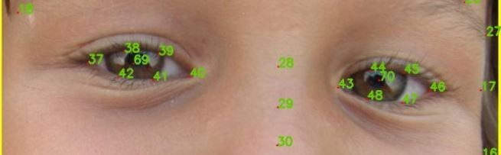

# Understanding Dlib’s Facial Landmark Detector

* + Dlib’s facial landmark detector is based on a paper by Vahid Kazemi and Josephine Sullivan, titled: **["One Millisecond Face Alignment with an Ensemble of Regression](http://www.csc.kth.se/~vahidk/face_ert.html) [Trees"](http://www.csc.kth.se/~vahidk/face_ert.html)**
  + 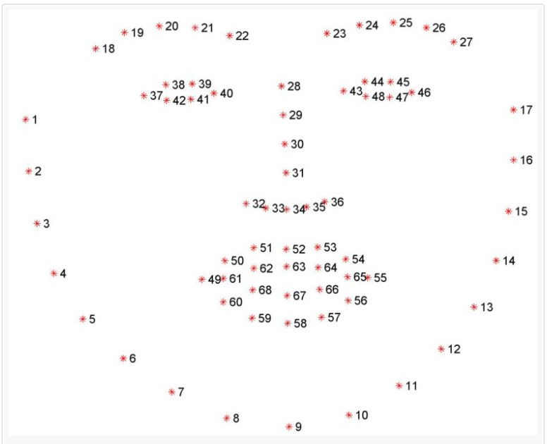It uses an ensemble of regression trees trained on the training set of labeled facial landmarks on an image
  + The pre-trained facial landmark detector inside the dlib library is used to estimate the location of 68 (x, y)-coordinates that map to facial structures on the face. The 68 landmark output is shown in the figure below. However, we utilised the 70 landmark model.

# Find aspect ratio of eyes and check status

* + We then calculate the aspect ratio to check whether eyes are opened or closed.
  + The eye is open if Eye Aspect ratio is greater than threshold. (Around 0.3)

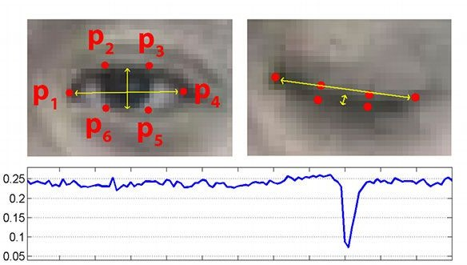

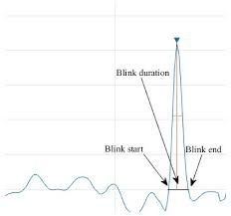

* + Assume time between two frames is 100 ms (varies between computers)
  + Blink will be valid if it lasts for 300 ms (3 frames). (Different for different people)
  + Person is drowsy if eye remains closed for more than 900 ms (9 frames)

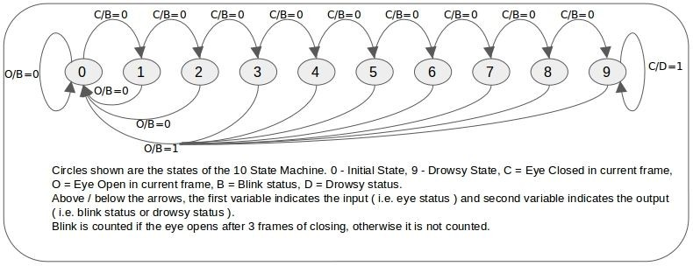

**Applications**

This can be used by riders who tend to drive for a longer period of time that may lead to accidents

**Code Requirements unicorn**

The example code is in Python (version 2.7 or higher will work).

**Dependencies**

import cv2

import imutils

import dlib

import scipy

**Description**

A computer vision system that can automatically detect driver drowsiness in a real-time video stream and then play an alarm if the driver appears to be drowsy.

**Algorithm**

Each eye is represented by 6 (x, y)-coordinates, starting at the left-corner of the eye (as if you were looking at the person), and then working clockwise around the eye.

It checks 20 consecutive frames and if the Eye Aspect ratio is less than 0.25, Alert is generated.

Relationship

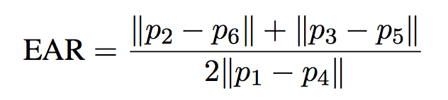

**Output**

Execution

To run the code, type python Drowsiness_Detection.py

python Drowsiness_Detection.py

**References**

* Association for Safe International Road Travel (ASIRT), Road Crash Statistics.http://asirt.org/initiatives/informingroadusers/road-safety-facts/road-crash-statistics, 2016
* [2] https://en.wikipedia.org/wiki/Microsleep
* [3] Journal of VLSI Signal Processing 23, 497–511 (1999) c °1999 Kluwer Academic Publishers. Manufactured in The Netherlands.
* [4] https://docs.opencv.org/trunk/d7/d8b/tutorial_py_face_de tection.html
* [5] Eye Detection Using Morphological and Color Image Processing Tanmay Rajpathaka, Ratnesh Kumar and Eric Schwartzb
* [6] A Robust Algorithm for Eye Detection on Grey Intensity Face without Spectacles- JCS&T Vol. 5 No. 3
* [7] Froba Kebbuck: Audio- and Video-Based Biometric Person Authentication, 3rd International Conference, AVBPA 2001, Halmstad, Sweden, June 2001. Proceedings, Springer. ISBN 3-540-42216-1.
* [8] Driver Drowsiness Detection using Eye-Closeness Detection (2016 12th International Conference on Signal-Image Technology & Internet-Based Systems)